EXPERIMENT – 1
Aim
To write a Python program to solve the 8-Puzzle Problem using the A* Search Algorithm.
Algorithm
- Define the initial state and the goal state of the puzzle.
- Use the Manhattan Distance heuristic to estimate the cost from the current state to the goal.
- Find the position of the blank tile (0).
- Generate all possible neighboring states by moving the blank tile in four directions (up, down, left, right).
- Store the states in a priority queue based on the evaluation function:
where:
  - g(n) = Cost from the initial state to the current state.
  - h(n) = Manhattan Distance heuristic.
- Repeat the process until the goal state is reached.
- Display the sequence of moves f
rom the initial state to the goal state.
Program :
from queue import PriorityQueue

goal = [[1,2,3],[4,5,6],[7,8,0]]

def h(s):
d = 0
for i in range(3):
for j in range(3):
if s[i][j]:
x, y = divmod(s[i][j]-1, 3)
d += abs(x-i) + abs(y-j)
return d
def solve(start):
pq = PriorityQueue()
pq.put((h(start), start))
seen = set()

while not pq.empty():
_, s = pq.get()
if s == goal:
print("Goal State Reached")
for r in s:
print(r)
return

seen.add(str(s))
x, y = [(i, j) for i in range(3) for j in range(3) if s[i][j] == 0][0]

for dx, dy in [(-1,0),(1,0),(0,-1),(0,1)]:
nx, ny = x+dx, y+dy
if 0 <= nx < 3 and 0 <= ny < 3:
t = [r[:] for r in s]
t[x][y], t[nx][ny] = t[nx][ny], t[x][y]
if str(t) not in seen:
pq.put((h(t), t))

start = [[1,2,3],[4,5,6],[7,0,8]]
OUTPUT: 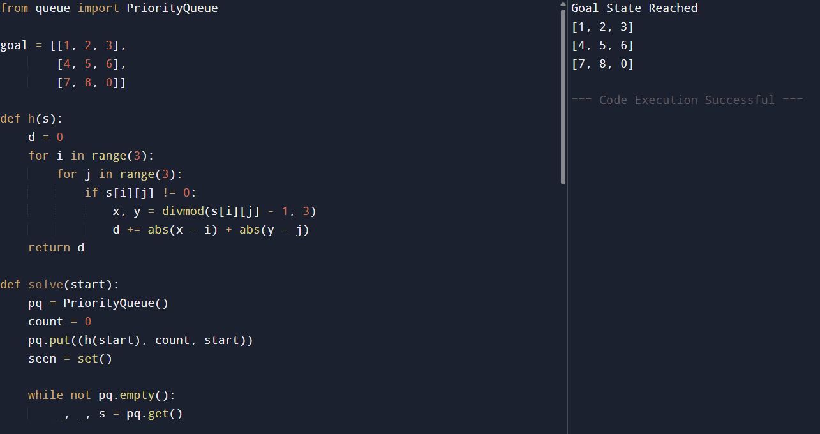

Result
Thus, the Python program to solve the 8-Puzzle Problem using the A* Search Algorithm was successfully implemented and executed, and the goal state was reached successfully.

EXPERIMENT – 02
Aim
To write a Python program to solve the 8-Queens Problem using the Backtracking algorithm.
Algorithm
- Start with an empty 8 × 8 chessboard.
- Place a queen in the first column at a safe position.
- Move to the next column and place another queen in a safe position.
- Before placing a queen, check that no other queen attacks it (same row, upper diagonal, or lower diagonal).
- If no safe position is found, backtrack by removing the previously placed queen.
- Repeat until all 8 queens are placed successfully.
- Display the final board configuration.

Program
def safe(board, row, col):
for i in range(col):
if board[row][i] == 1:
return False

i, j = row, col
while i >= 0 and j >= 0:
if board[i][j] == 1:
return False
i -= 1
j -= 1

for row in range(7, -1, -1): # Try rows from bottom to top
if safe(board, row, col):
board[row][col] = 1

if queen(board, col + 1):
return True

board[row][col] = 0

return False

board = [[0] * 8 for _ in range(8)]

if queen(board, 0):
print("Solution:")
for row in board:
print(row)
else:
print("No Solution")
OUTPUT
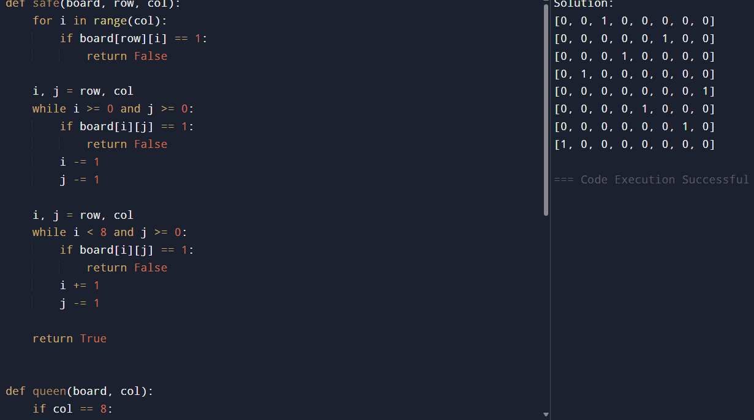
Result:
Thus, the Python program to solve the 8-Queens Problem using the Backtracking algorithm was successfully implemented and executed, producing a valid arrangement of eight queens on the chessboard.

EXPERIMENT 03
Aim
To write a Python program to solve the Water Jug Problem using Breadth-First Search (BFS).

Algorithm
- Start with both jugs empty.
- Represent each state as (Jug1, Jug2).
- Generate all possible next states:
- Use Breadth-First Search (BFS) to explore all possible states.
- Stop when the required amount of water is obtained.
- Display the sequence of states from the initial state to the goal state.
Program
from collections import deque
def water_jug(jug1, jug2, target):
visited = set()
q = deque([((0, 0), [])])
while q:
(x, y), path = q.popleft()

if (x, y) in visited:
continue
visited.add((x, y))
path = path + [(x, y)]

if x == target or y == target:
print("Solution Path:")
for state in path:
print(state)
return

next_states = [
(jug1, y), # Fill Jug1
(x, jug2), # Fill Jug2
(0, y), # Empty Jug1
(x, 0), # Empty Jug2
(x - min(x, jug2 - y), y + min(x, jug2 - y)), # Jug1 -> Jug2
(x + min(y, jug1 - x), y - min(y, jug1 - x)) # Jug2 -> Jug1
]

for state in next_states:
if state not in visited:
q.append((state, path))

# Jug capacities: 4L and 3L
# Target: 2L
water_jug(4, 3, 2)
OUTPUT:
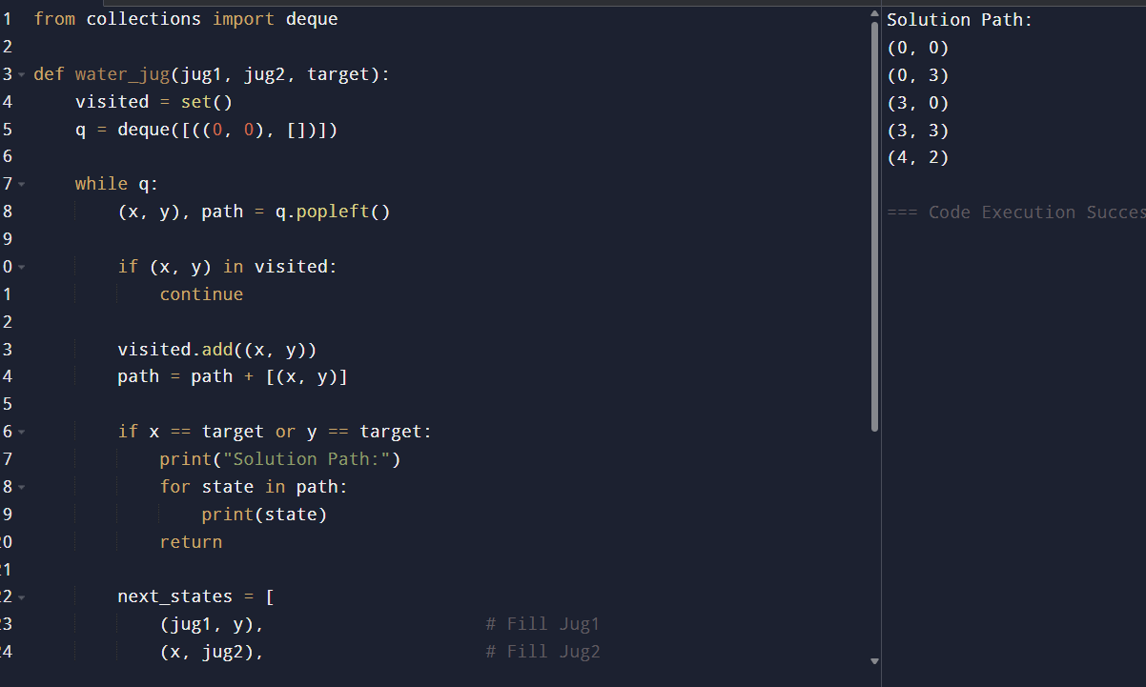
Result
Thus, the Python program to solve the Water Jug Problem using the Breadth-First Search (BFS) algorithm was successfully implemented and executed.

EXPERIMENT 04
Aim
To write a Python program to solve the Crypt-Arithmetic Problem using Backtracking.
Algorithm
- Identify all unique letters in the given equation.
- Assign a unique digit (0–9) to each letter.
- Ensure that no two letters have the same digit.
- Check that the leading letters are not assigned zero.
- Substitute the digits into the equation.
- If the equation is satisfied, display the solution.
- Otherwise, continue searching until a valid assignment is found.

Program
from itertools import permutations

letters = ('S', 'E', 'N', 'D', 'M', 'O', 'R', 'Y')

for p in permutations(range(10), 8):
S, E, N, D, M, O, R, Y = p

if S == 0 or M == 0:
continue

SEND = 1000*S + 100*E + 10*N + D
MORE = 1000*M + 100*O + 10*R + E
MONEY = 10000*M + 1000*O + 100*N + 10*E + Y

if SEND + MORE == MONEY:
print("Solution Found")
print("SEND =", SEND)
print("MORE =", MORE)
print("MONEY =", MONEY)
break
OUTPUT
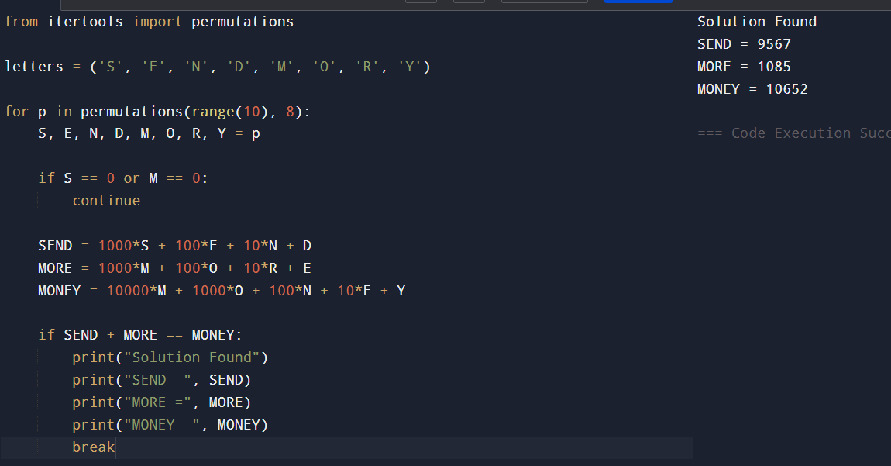
Result:
Thus, the Python program to solve the Crypt-Arithmetic Problem using the Backtracking approach was successfully implemented and executed.

EXPERIMENT 05
Aim
To write a Python program to solve the Missionaries and Cannibals Problem using Breadth-First Search (BFS).

Algorithm
- Represent each state as (Missionaries Left, Cannibals Left, Boat Side).
- Start with the initial state (3, 3, 1), where the boat is on the left bank.
- Generate all valid successor states by moving one or two people across the river.
- Reject any state where cannibals outnumber missionaries on either bank.
- Use Breadth-First Search (BFS) to explore all valid states.
- Stop when the goal state (0, 0, 0) is reached.
- Display the sequence of states from the initial state to the goal state.
Program
from collections import deque

def valid(m, c):
return (m == 0 or m >= c) and (3 - m == 0 or 3 - m >= 3 - c)

def solve():
start = (3, 3, 1)
goal = (0, 0, 0)

q = deque([(start, [start])])
visited = set()

while q:
state, path = q.popleft()

if state == goal:
print("Solution Path:")
for s in path:
print(s)
return

if state in visited:
continue

visited.add(state)

m, c, boat = state
moves = [(1,0), (2,0), (0,1), (0,2), (1,1)]

for dm, dc in moves:
if boat == 1:
nm, nc, nb = m-dm, c-dc, 0
else:
nm, nc, nb = m+dm, c+dc, 1

if 0 <= nm <= 3 and 0 <= nc <= 3 and valid(nm, nc):
q.append(((nm, nc, nb), path + [(nm, nc, nb)]))

solve()

OUTPUT
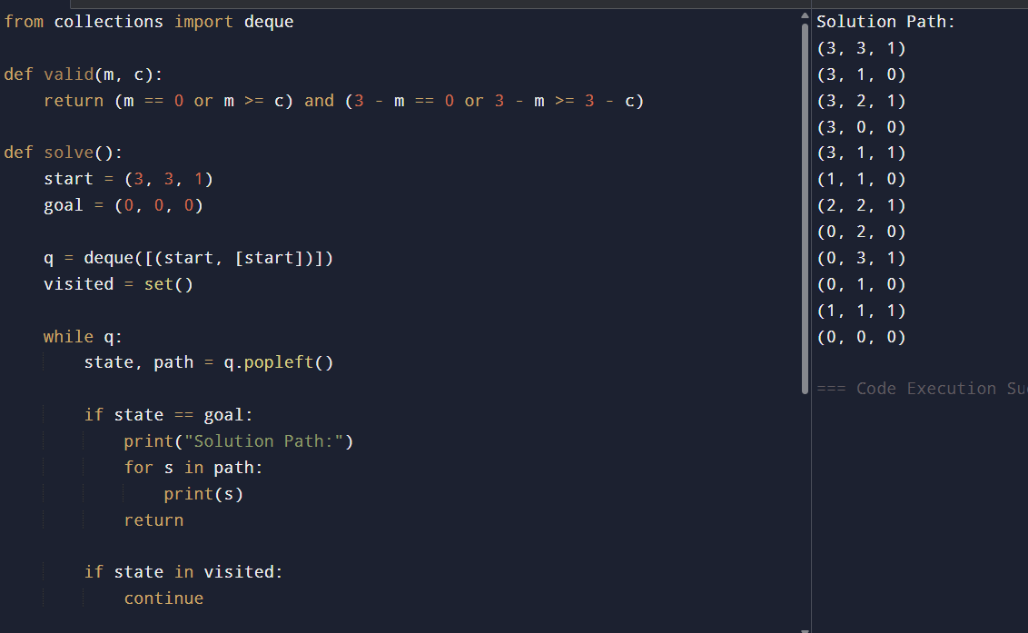
Result:
Thus, the Python program to solve the Missionaries and Cannibals Problem using the Breadth-First Search (BFS) algorithm was successfully implemented and executed.

EXPERIMENT 06
Aim
To write a Python program to solve the Vacuum Cleaner Problem using a simple reflex agent.
Algorithm
- Start with the vacuum cleaner at a given location (A or B).
- Check whether the current location is Dirty or Clean.
- If the location is Dirty, clean it.
- If the location is Clean, move to the other location.
- Repeat the process until both locations are clean.
- Display each action performed by the vacuum cleaner.
Program
def vacuum_cleaner(room, location):
while True:
if room["A"] == "Clean" and room["B"] == "Clean":
print("Both rooms are clean.")
break

if room[location] == "Dirty":
print("Cleaning Room", location)
room[location] = "Clean"
else:
if location == "A":
print("Moving to Room B")
location = "B"
else:
print("Moving to Room A")
location = "A"

# Initial State
room = {
"A": "Dirty",
"B": "Dirty"
}

vacuum_cleaner(room, "A")

OUTPUT:
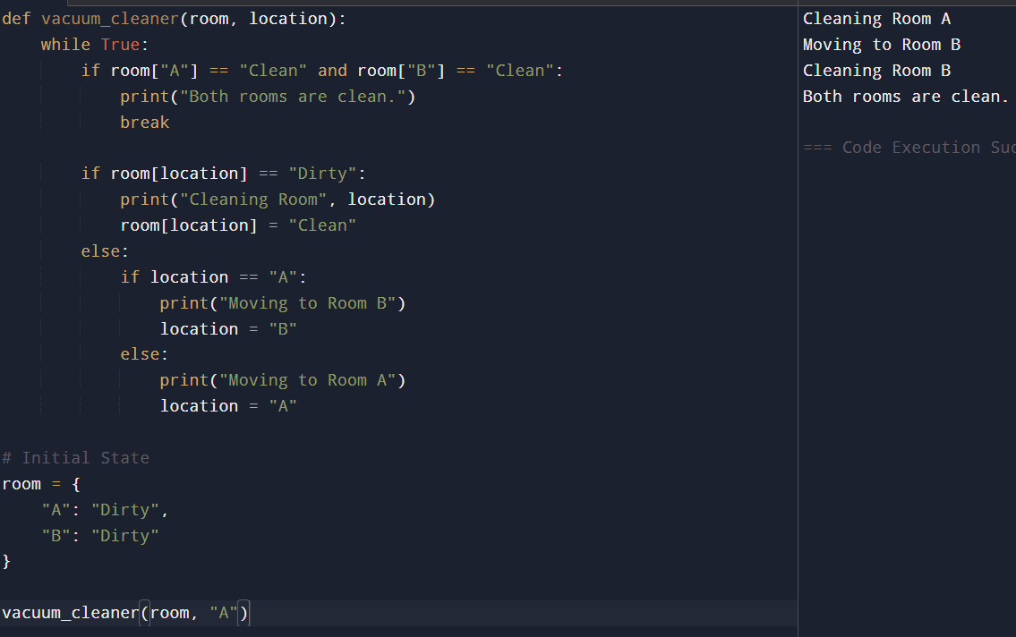

Result:
Thus, the Python program to solve the Vacuum Cleaner Problem using a Simple Reflex Agent was successfully implemented and executed.

EXPERIMENT 07
Aim
To write a Python program to implement the Best First Search (BES) algorithm.
Algorithm
- Create a graph with nodes and heuristic values.
- Start from the source node.
- Insert the source node into a priority queue.
- Select the node with the lowest heuristic value.
- If the selected node is the goal, stop the search.
- Otherwise, add its unvisited neighbors to the priority queue.
- Repeat until the goal node is reached.
- Display the path from the source to the goal.

Program
from queue import PriorityQueue

graph = {
'A': [('B', 4), ('C', 3)],
'B': [('D', 5), ('E', 2)],
'C': [('F', 6), ('G', 1)],
'D': [],
'E': [],
'F': [],
'G': []
}

def best_first_search(start, goal):
pq = PriorityQueue()
pq.put((0, start))
visited = []

while not pq.empty():
cost, node = pq.get()

if node not in visited:
print(node, end=" ")
visited.append(node)

if node == goal:
print("\nGoal Reached")
return

for neighbor, h in graph[node]:
if neighbor not in visited:
pq.put((h, neighbor))

best_first_search('A', 'G')

OUTPUT:
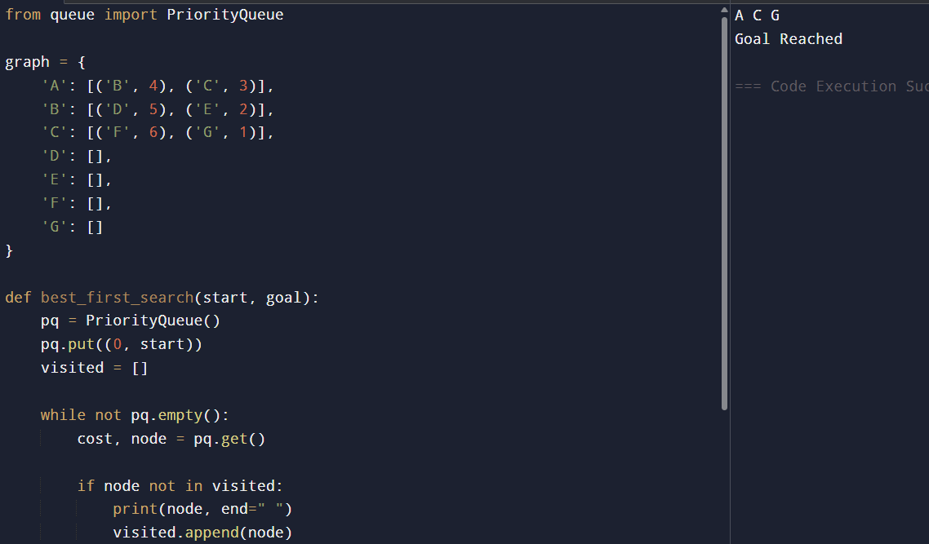
Result:
Thus, the Python program to implement the Best First Search (BES) algorithm was successfully executed, and the goal node was reached using heuristic values.

EXPERIMENT 08
Aim
To write a Python program to implement the Depth First Search (DFS) algorithm.
Algorithm
- Create a graph using an adjacency list.
- Create an empty set to store visited nodes.
- Define a recursive DFS function.
- Visit the current node and mark it as visited.
- Recursively visit all unvisited adjacent nodes.
- Continue until all reachable nodes are visited.
- Display the DFS traversal.
Program
# Python program to implement DFS

graph = {
'A': ['B', 'C'],
'B': ['D', 'E'],
'C': ['F'],
'D': [],
'E': ['F'],
'F': []
}

visited = set()

def dfs(node):
if node not in visited:
print(node, end=" ")
visited.add(node)
for neighbor in graph[node]:
dfs(neighbor)

print("DFS Traversal:")
dfs('A')

OUTPUT:
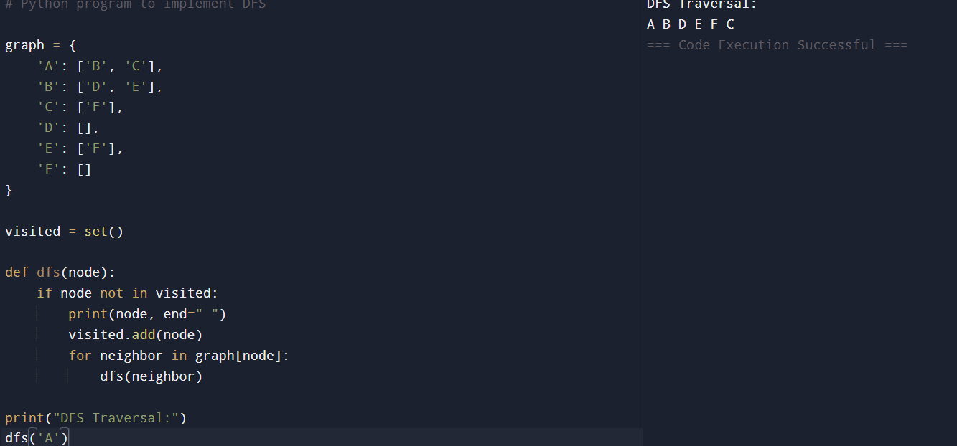

Result:
Thus, the Python program to implement the Depth First Search (DFS) algorithm was written, executed successfully, and the DFS traversal of the graph was obtained.

EXPERIMENT 09
Aim
To write a Python program to implement the Travelling Salesman Problem (TSP).
Algorithm
- Define the distance matrix between cities.
- Consider the first city as the starting city.
- Generate all possible routes using permutations.
- Calculate the total distance for each route.
- Find the route with the minimum distance.
- Display the shortest route and its cost.
Program
from itertools import permutations

graph = [
[0, 10, 15, 20],
[10, 0, 35, 25],
[15, 35, 0, 30],
[20, 25, 30, 0]
]

n = len(graph)
cities = list(range(1, n))

min_cost = float('inf')
best_path = ()

for path in permutations(cities):
cost = graph[0][path[0]]
for i in range(len(path) - 1):
cost += graph[path[i]][path[i + 1]]
cost += graph[path[-1]][0]

if cost < min_cost:
min_cost = cost
best_path = path

print("Shortest Path: ", (0,) + best_path + (0,))
print("Minimum Cost:", min_cost)
OUTPUT:
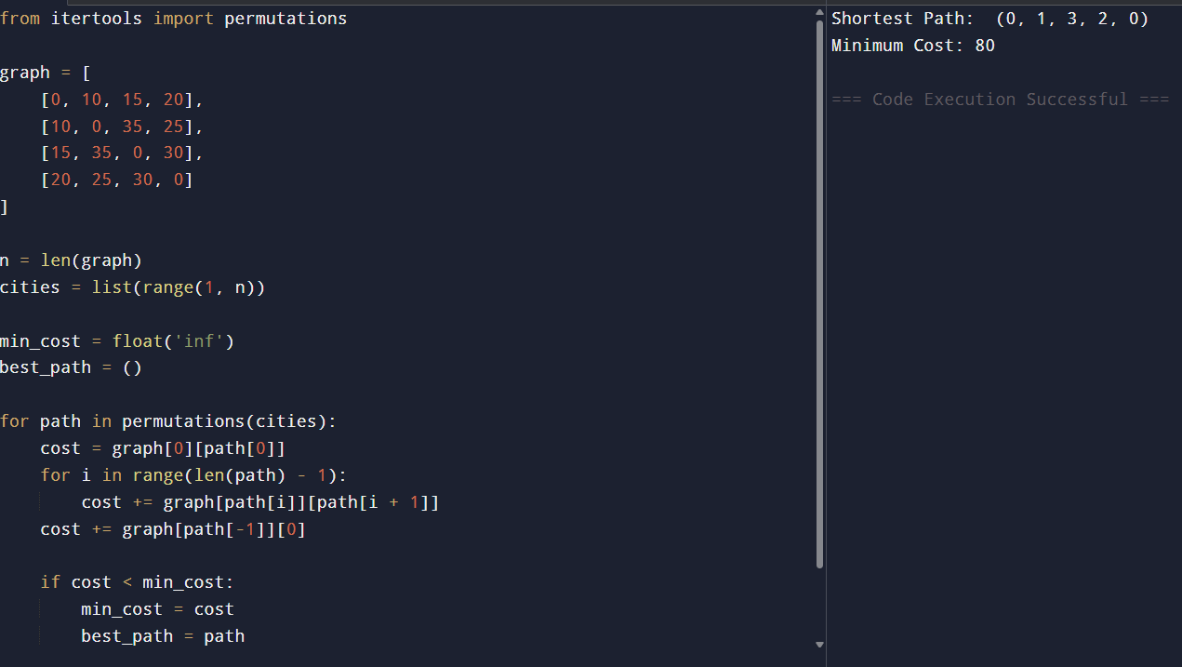

Result:
Thus, the Python program to implement the Travelling Salesman Problem (TSP) was written, executed successfully, and the shortest path with the minimum travel cost was obtained.

EXPERIMENT 10
Aim
To write a Python program to implement the A* (A-Star) algorithm.
Algorithm
- Create a graph with nodes and edge costs.
- Assign heuristic values to each node.
- Initialize the open and closed lists.
- Select the node with the lowest f(n) = g(n) + h(n).
- Expand the selected node and update its neighbors.
- Repeat until the goal node is reached.
- Display the shortest path.
Program
graph = {
'A': {'B': 1, 'C': 3},
'B': {'D': 3, 'E': 6},
'C': {'F': 5},
'D': {},
'E': {'F': 2},
'F': {}
}

heuristic = {
'A': 6,
'B': 4,
'C': 4,
'D': 3,
'E': 2,
'F': 0
}

def a_star(start, goal):
open_list = [start]
closed_list = []
g = {start: 0}
parent = {start: None}

while open_list:
current = min(open_list, key=lambda x: g[x] + heuristic[x])

if current == goal:
path = []
while current:
path.append(current)
current = parent[current]
return path[::-1]

open_list.remove(current)
closed_list.append(current)

for neighbor, cost in graph[current].items():
if neighbor in closed_list:
continue

new_cost = g[current] + cost

if neighbor not in open_list:
open_list.append(neighbor)
elif new_cost >= g.get(neighbor, float('inf')):
continue

g[neighbor] = new_cost
parent[neighbor] = current

return None

print("Shortest Path:", a_star('A', 'F'))
OUTPUT:
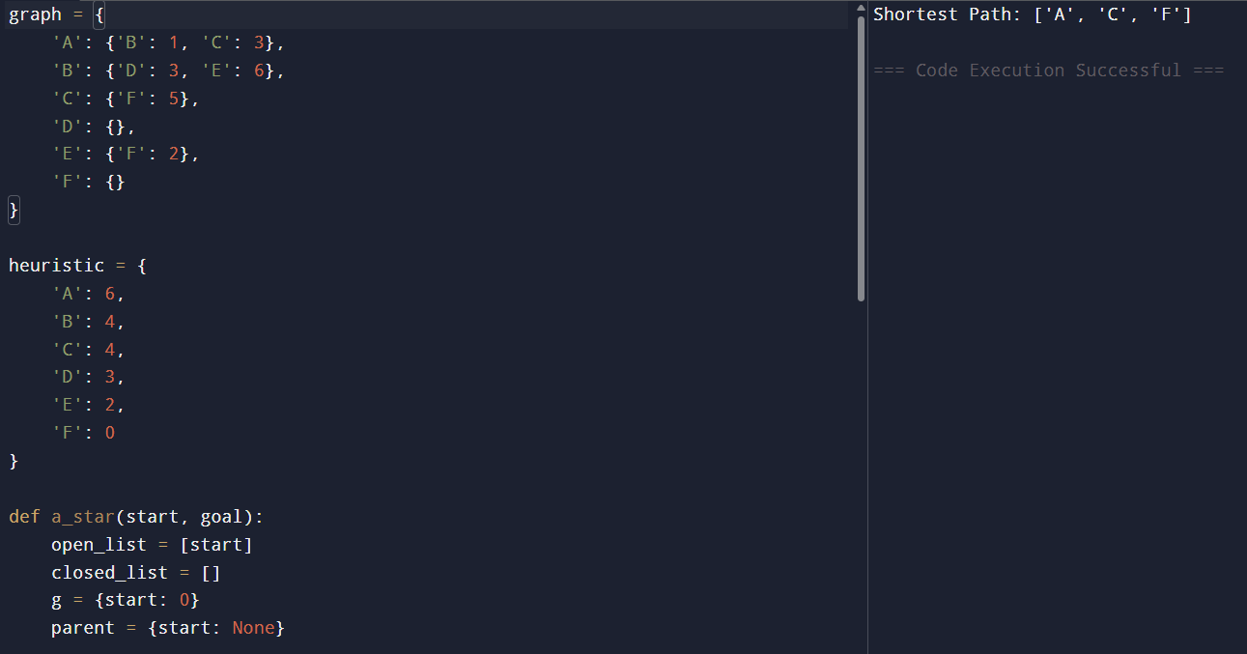

Result:

